# Market Segmentation

## Meaning & Concept

Market segmentation is the process of dividing a larger market into smaller groups of consumers with similar needs or characteristics. This allows businesses to create more targeted marketing strategies and tailor their products and services to specific customer groups.

## Basis of segmentation

There are four main types of market segmentation: demographic, geographic, psychographic, and behavioural. Let's take a look at some real-life examples of each:

1. Demographic segmentation:

This type of segmentation divides the market based on characteristics such as age, gender, income, education level, occupation, and family status. An example of demographic segmentation would be a company that targets its products specifically to young adults aged 18-24 who are attending college. They might offer products such as textbooks, school supplies, and college apparel to this specific demographic.

1. Geographic segmentation:

This type of segmentation divides the market based on geographic location, such as country, region, city, or even neighbourhood. An example of geographic segmentation would be a chain of convenience stores that offers different products and services in urban areas versus rural areas. In urban areas, they might focus on selling ready-to-eat meals and quick snacks, while in rural areas they might offer more products for outdoor activities such as camping and fishing.

1. Psychographic segmentation:

This type of segmentation divides the market based on consumers' lifestyle, personality traits, values, interests, and behaviours. An example of psychographic segmentation would be a clothing company that targets customers who value sustainability and eco-friendliness. They might offer products made from sustainable materials and promote their brand as environmentally responsible.

1. Behavioural segmentation:

This type of segmentation divides the market based on consumers' purchasing behaviour, such as their buying patterns, loyalty to certain brands, and product usage. An example of behavioural segmentation would be a company that offers loyalty programs to customers who frequently purchase their products. They might offer rewards such as discounts, free merchandise, or exclusive access to new products or events.

## Selection Of Segments

After identifying the basis of segmentation, businesses need to select the segments they want to target. The selection process involves evaluating the attractiveness of each segment based on factors such as size, growth potential, profitability, competition, and compatibility with the business's capabilities.

## Market Segmentation strategies

Market segmentation strategies are the different approaches that businesses can take when dividing their market into smaller, more targeted groups. Here are some examples of market segmentation strategies:

1. Undifferentiated marketing:

This strategy involves treating the entire market as a single segment and using the same marketing mix for all customers. This approach is most effective when there are no significant differences between customer needs or when the business has limited resources to devote to market research and segmentation. An example of undifferentiated marketing is the marketing strategy used by Coca-Cola. Coca-Cola targets all customers regardless of their age, gender, location or lifestyle, and uses the same marketing mix for all customers.

1. Differentiated marketing:

This strategy involves targeting multiple segments with different marketing strategies. This approach is most effective when there are clear differences in customer needs and preferences, and the business has the resources to develop multiple marketing campaigns. An example of differentiated marketing is the marketing strategy used by car manufacturers such as Ford and General Motors. These companies offer different models and features to appeal to different customer segments, such as families, young professionals, or outdoor enthusiasts.

1. Concentrated marketing:

This strategy involves focusing on a single segment and developing a highly specialized marketing strategy for that segment. This approach is most effective when there is a small but profitable niche market with specific needs and preferences. An example of concentrated marketing is the marketing strategy used by luxury car manufacturers such as Bentley or Rolls-Royce. These companies focus on the ultra-high-end market segment, offering highly customized cars with a focus on exclusivity and prestige.

1. Micromarketing:

This strategy involves targeting individuals or very small groups with customized marketing strategies. This approach is most effective when there is a high degree of variability in customer needs and preferences, and the business has the resources to gather detailed data about individual customers. An example of micromarketing is the marketing strategy used by online retailers such as Amazon. Amazon uses data on customer preferences and behavior to personalize product recommendations, email campaigns, and promotional offers for individual customers.

## Target Marketing

Once a business has identified its target segments, it needs to develop marketing strategies that are tailored to the needs and characteristics of those segments. This involves creating messages and promotions that resonate with the target customers and delivering them through the most effective channels.

## Product Positioning

Product positioning involves creating a unique image and identity for a product or service in the minds of the target customers. This involves identifying the key benefits and features of the product that are most important to the target customers and emphasizing them in the marketing message. Product positioning can be a powerful tool for differentiating a product from its competitors and creating a strong brand image.

# PRODUCT DECISIONS

## What Is a Product?

Product is anything that can be offered in a market for **attention, acquisition, consumption** or **experience** that might satisfy a need, want or demand

From organization's perspective it is the Core of the offer made to the customers

## Levels of Product

### Potential Product

Which includes all augmentations & transformations a product might undergo in future

Future updates and upgrades, compatibility & connectivity with other gadgets & devices, etc.

### Augmented Product

Which includes additional features & benefits, that create differentiation

Unique & Differentiated benefits — 4K/ 8K Camera, High Refresh rate Display, latest processor, etc.

### Expected Product

Which contains attributes & benefits, that buyer normally expects

Expected benefits — Good Quality Photos, speed, longer battery life etc.

### Generic Product

Which contains only necessary attributes for functioning of Product

Features — Display, Camera, RAM, Battery Life etc.

### Core Product

Which satisfies fundamental Need

Communication & Mobility

## Classification of Product (based on Durability & Tangibility)

## Product

## Nondurable Goods

* Tangible
* Used in I or few Uses
* E.g. FMCG

## Durable Goods

* Tangible
* Survive many Uses
* E.g. Consumer Durables

## Services

* Intangible, inseparable, perishable, variable
* E.g. Hairstyle, Movies, Theme park etc.

## Classification of Product (based on Use)

### Consumer products

Consumer products are products for the personal consumption

Classified by how consumers buy them

#### Convenience products

Customer usually buys

* Frequently
* Immediately
* With minimum comparison and buying effort

E.g. Newspapers Chocolate/ Candy FMCG

#### Shopping products

Customer compares carefully on

* Suitability
* Quality
* price
* Style

E.g. Clothes Electrical Appliances

#### Specialty products

Products with unique characteristics or brand identification

A significant group of buyers is willing to make a special purchase effort

E.g. High-priced Designer Dresses, Gold/ Diamond Ornaments, Cars

#### Unsought products

Customer does not know about or does not normally think of buying

Purchase of such products arises due to danger or the fear of danger and not out of a desire buy it.

E.g. Health insurance, Fire Extinguishers

### Business products

Products purchased for further processing or for use in conducting a business.

Differentiates from consumer products majorly in terms of Buying Motives, Buying Process and Buying Habits

Broadly classified by the purpose for which the product is purchased

#### Materials and parts

Include raw materials, manufactured materials and parts, usually sold directly to the industrial users

E.g. Lumber, Iron, Cement, Plastic

#### Capital Items

Capital items are business products that aid in the buyer's production or operations

E.g. Buildings, Elevators, Computers/ Laptops, Machinery

## The Components of Product Personality

### Product attributes

Quality, Features, Style & Design

### Branding

Name, Logo, Design, Symbol, Tagline

### Packaging

Look, Feel, Size, Shape, Material

### Labelling

Describes attributes & provides promotion

### Product support services

After sales service, Warranty, Repair, Replacement

## Product Mix & Product Line

### Product Mix of HUL

### Product Mix of Samsung

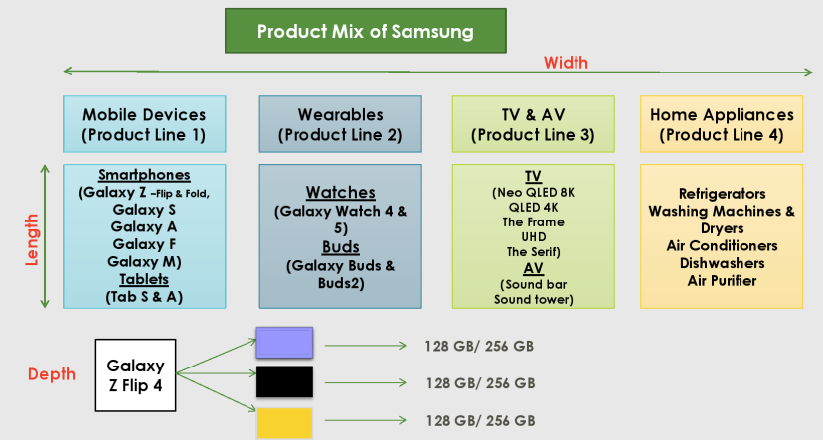

## Strategies for Managing Product Line

|  |  |
| --- | --- |
| Product line stretching Company lengthens its product line beyond its current range   * Downward Stretch (Samsung M series) * Upward Stretch (Maruti Nexa) * Two-way Stretch (Combination of both — E.g. BBK Group) | Product line filling Companies add more items within the present range of the line   * More profits * Satisfying dealers * Excess capacity * Plugging holes to fend off competitors |

## Product Life Cycle

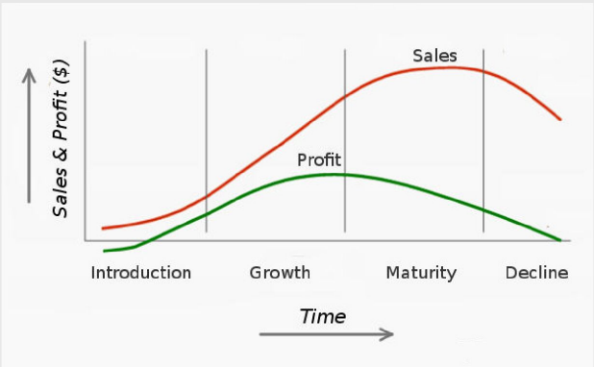

### Four Key Assumptions:

* Limited Life of Products
* Products' sale pass through multiple & distinct stages
* Profits rise & fall at different stages
* At each stage — different strategies for Marketing, Finance, Manufacturing, HR
* Applicable to analyse — Product Category, Product & Brand
* Length of PLC and each stage differs from product to product
* Helps managers to think about challenges at different stages

### Introduction

* Slow sales growth and non-existent profits due to heavy expenses
* Promotional expenses to Sales ratio are highest due to the need of:
* Informing potential consumers
* Inducing product trial
* Securing distribution in retail outlets

### Growth

* Rapid Market acceptance and substantial profit improvement
* Promotional expenses are maintained or increased to compete effectively
* Promotional expenses to Sales ratio reduce — large sales volume
* Strategies:
  + Improved offering (superior quality, new features/ styling)
  + New variants
  + New target segments
  + Increase distribution coverage
  + Lower price to attract more segments

### Maturity

* 3 Phases:
  + **Growth** (Sales growth slows down, no new distribution channels)
  + **Stable** (Sales per capita flatten due to market saturation, as most potential buyers have already purchased)
  + **Decaying Maturity** (Sales starts declining, as customers starts switching to other products
* 3 Remedial Ways:
  + Market Modification
    - Expand No. of Users — Convert non-users, Enter New Segments, Attract Competitors' customers
    - Increase Usage Rate - More consumption, More occasions, new ways of consumption (E.g. Cadbury, Kurkure)
  + Product Modification
    - Quality improvement
    - Additional Features
    - Style improvement
  + Marketing Program Modification
    - Price
    - Distribution
    - Communication

### Decline

* Sales show downward drift, Profits erode
* Remedial Ways:
  + **Eliminate Weak Products**
  + **Harvesting** (gradually reducing product's cost)
  + **Divesting** (sell it to another firm)

## Stages of the PLC

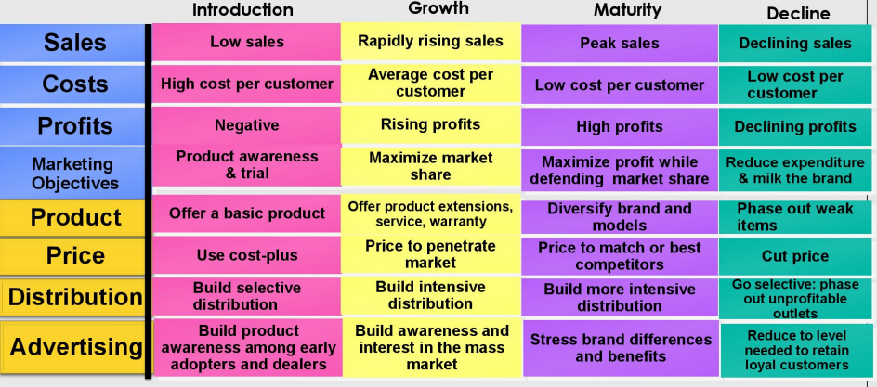

## Style, Fashion, and Fad Life Cycles

### Style Life Cycles

|  |  |
| --- | --- |
|  | * A basic & distinctive mode of Expression * E.g., Clothing — Formal, Business Casual, Ethnic etc. * Style can last for generations and go in & out of vogue |

### Fashion Life Cycles

|  |  |
| --- | --- |
|  | * Currently accepted or popular style in a given field * 4 stages: Distinctiveness, Emulation (Initial imitation), Mass Fashion 7 Decline * Length is hard to predict - End when consumers look for missing attributes |

### Fad Life Cycles

|  |  |
| --- | --- |
|  | * Fashion that comes quickly in public view, adopted, peak early & decline fast * E.g. Amazon Kindle * Decline fast because don't satisfy strong need |

# New Product Development

* It is a process of developing a new offering (physical good or service) for the market
* It involves development of **original products, product improvements, product modifications,** and **new brands** through the firm's own R & D efforts
* NPD is done either to **compete** with competitor's product/service or to **improve** an already established product

## Types of New Product

* New-to-the-world
  + An Invention
  + Potential customers needs to be educated about it
  + The designs can be protected through patents
  + Popularity of new product can boost reputation of company
  + E.g. Amazon Kindle, Echo Dot, Walkman, Iphone
* New-to-the-firm
  + A product that the company has never made, but available in the market
  + company does not require to create knowledge on how product works
  + The product must fit the image of what the company specializes in
  + E.g. Google+
* Addition to existing product line
  + Launching new product variants under existing product line
  + Helps in better segmentation
  + E.g. Samsung Galaxy Smartphone series
* Improved and revised
  + Existing products/ brands are further improved with features/ technology
  + Actual value increased in the long run
  + E.g.Activa 7G
* Repositioning
  + Changing the perception in the mind of the consumer.
  + Generating revenue from an existing product
  + E.g. Maggi/ Hero MotoCorp

## Factors Contributing NPD

* Change in Consumer Preference (Smartphones)
* Change in Technology (Android)
* Govt. Policy (Tally)
* Competition (BBK)
* Environmental Threat (McDonalds/ KFC)

## NPD Process

New product development (NPD) is the process of creating and bringing a new product or service to market. Developing a successful new product requires a well-defined strategy that considers market needs, customer preferences, technological feasibility, and financial viability.

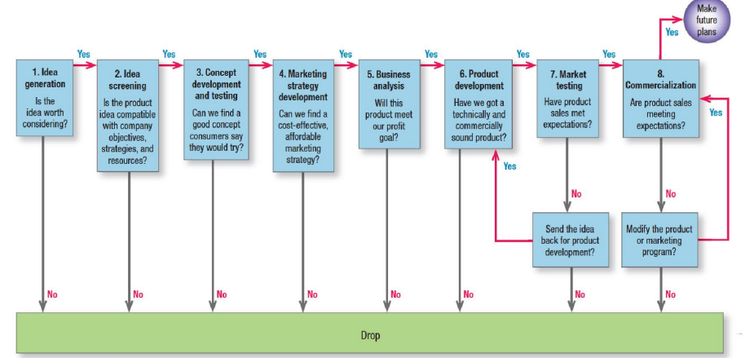

### Idea Generation Tools

* Observing Customers
* Interviewing Customers
* Interviewing Employees
* Interviewing Experts
* Analyzing the Competition
* Crowdsourcing

### Idea Screening

* Product-Idea Rating Device

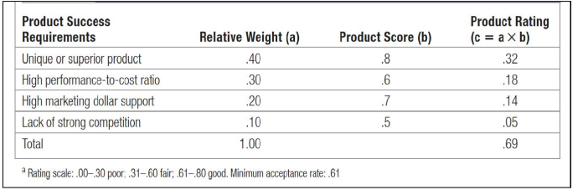

* Estimate Product's overall Probability of Success

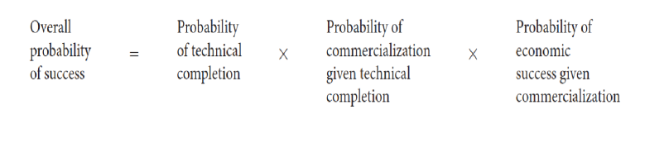

### Concept Development & Testing

Presenting the product concept to target consumers, physically or symbolically, and getting their reactions.

* Communicability and believability
  + Are the benefits clear to you and believable?" If the scores are IOW, the concept must be refined or revised.
* Need level
  + 'Do you see this product solving a problem or filling a need for you?' The stronger the need, the higher the expected consumer interest.
* Gap level
  + 'Do other products currently meet this need and satisfy you?' The greater the gap, the higher the expected consumer interest.
  + Marketers can multiply the need level by the gap level to produce a need-gap score. A high score means the consumer sees the product as filling a strong need, not satisfied by available alternatives.
* Perceived value
  + "Is the price reasonable in relationship to value?' The higher the perceived value, the higher is expected consumer interest.
* Purchase intention
  + 'Would you (definitely, probably, probably not, definitely not) buy the product?'
* User targets, purchase occasions, purchasing frequency
  + "Who would use this product, when, and how often?'

### Market Strategy Development

* Essential aspects to be considered
  + Target market's size, structure, & behavior
  + Planned brand positioning
  + Sales, Market share & Profit goals in first few years
  + Planned price, distribution strategy, and marketing budget for the first year
  + Long-run sales & profit goals and marketing-mix strategy over time

### Business Analysis

* Estimating total sales
* Product Life-Cycle Sales for 3 Types of Products

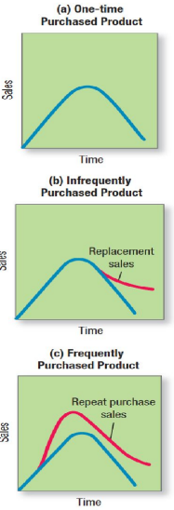

* Estimating Costs & Profits

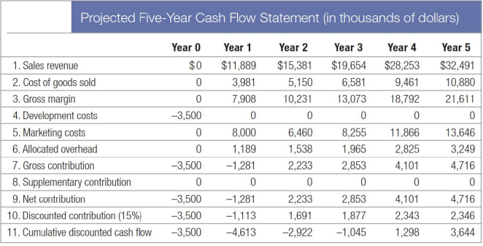

### Product Development

* Physical prototypes
* Customer tests: alpha & beta testing
  + **Alpha** testing helps validate the quality of the product
  + **Beta** testing helps to obtain **real-world feedback** to ensure you're building products that your customers actually like

### Market Testing

* Consumer-goods market testing
* Business-goods market testing
* Methods
  + Sales-wave research
    - A technique used to test consumer reaction to new products prior to full-scale commercialization
  + Simulated Test Marketing
    - Consumers are exposed to a simulated purchase situation to gauge the their reactions to a product, advertising or marketing mix variations
  + Controlled Test Marketing
    - Researcher offers the marketer a panel of stores, where the checkout scanner data is monitored to measure initial and repeat purchases, along with the sales of competitive products
  + Test Markets
    - The company selects a **small number of representative cities** in which to trial the full marketing mix prior to a new product launch

### Commercialization

* Where (Geographic Strategy)
* To Whom (Target-Market Prospects)
* How (Introductory Market Strategy)

# Pricing Decisions

## Overview of Pricing

• The amount of **money charged** for a product or service, or the sum of the values that **consumers exchange for the benefits** of having or using the product or service.

• The only element among the 4Ps, that **generates revenues**

• The **most flexible** **element** of Marketing mix

• Important **determinant of the profitability** of business

• One 'P" that has been **dramatically affected by** the use of the **Internet**.

• How companies’ price

* + Small companies: boss
  + Large companies: division/product manager’s line

## Which Factors Affects the Pricing Decisions from Organization's Perspective?

### Internal Factors

* Marketing Objectives
  + Survival/ Profit maximization/ Market share leadership/ Product quality leadership
  + E.g. LG
* Marketing Mix Strategies
  + Careful coordination with other marketing mix elements
  + E.g. McVities Digestive Biscuits
* Costs
  + Variable/ Fixed/ Total Costs
* Organizational Considerations
* Price setters: CEO/ Top Mgt. in small companies, Product line Mgr. in large companies

### External Factors

* Nature of Market and Demand
  + Monopoly/ Monopolistic/ Oligopoly; price Elasticity of Demand
* Competition
  + Competitors' Costs, Prices and Offers
* Other Environmental Elements
  + Political, Economical, Social, Technological, Legal

## How companies should price

* Understanding of consumer Psychology pricing
* a systematic approach to setting, adapting, and changing prices

## Consumer Psychology and Pricing

* Purchase decisions
  + How consumers perceive prices
  + What they consider the current actual price to be
* Customers may have predetermined perceptions on:
  + **Lower price threshold** - below which prices signal inferior or unacceptable quality
  + **Upper price threshold** - above which prices are prohibitive and the product appears not worth the money

## How Consumers arrive at their Perceptions of Pricing?

* Reference Prices
  + Comparing an observed price to internal reference price they remember (previously advertised/ paid price) or an external frame of reference such as "regular retail price" by the competitors
* Image Pricing
  + Consumers perceive price as an indicator of quality
  + Effective with ego-sensitive products such as perfumes, expensive cars, and designer clothing
* Pricing Cues
  + Customers perceive an item priced at $299 to be in the $200 rather than the $300 range
  + Useful when there is a mental price break at the higher, rounded price

## How to Set the Price?

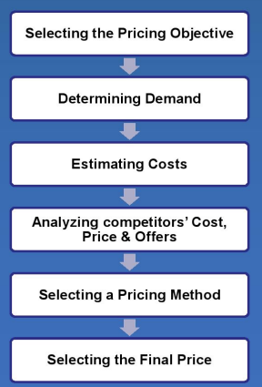

### Step 1: Selecting the Pricing Objective

* + Short term Profit
    - Maximize current profits, cash flow & rate of ROI
    - Based on the demand estimates & costs associated with alternative prices
  + Market Penetration
    - Maximize Market share and increase the sales volume by setting lower price (E.g. OYO Rooms, Jio)
  + Market Skimming
    - While unveiling a new technology/ experience set high prices to 'skim the cream' off the market & then slowly drop the price (E.g. Sony)
  + Quality Leadership
    - Positioning of Quality leader in the market (E.g. Starbucks, BMW, Apple)

### Step 2: Determining Demand

* + To understand what affects price sensitivity
* Customers are less price sensitive when:
* (1) There are few or no substitutes or competitors
* (2) They do not readily notice the higher price
* (3) They are slow to change their buying habits
* (4) They think the higher prices are justified
* (5) Price is only a small part of the total cost of obtaining, operating, and servicing the product over its lifetime

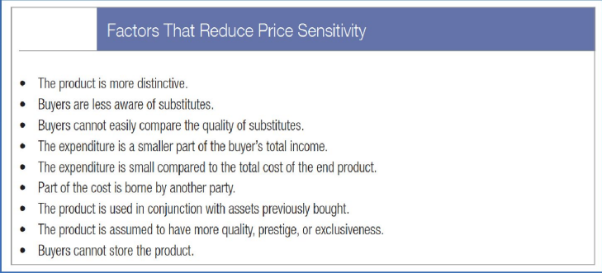

* + Estimating demand curves
    - Surveys, price experiments, & statistical analysis

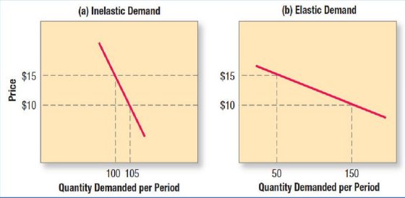

### Step 3: Estimating Costs

* + Charge a price that covers cost of producing, distributing, promoting and selling the product, including a fair return for its effort and risk
  + Fixed Vs. Variable Costs; Total Costs; Average Cost (cost per unit)

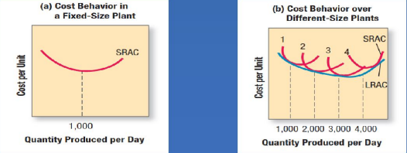

* + Accumulated production
    - Experience/learning curve

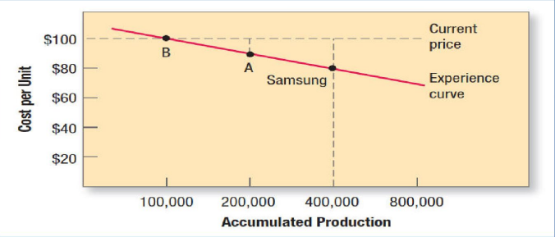

* + Target costing
* (Price) — (desired profit margin)
* Examine each cost element design, engineering, manufacturing, sales — and bring down costs
* But Cost cutting should not affect the brand promise and value delivered (E.g. Tata Nano)
* E.g. Despite the early success of the PT Cruiser, Chrysler chose to squeeze out more profit by avoiding certain redesigns and cutting costs with cheaper radios and inferior materials. Once a best-selling car, the PT Cruiser was eventually discontinued

### Step 4: Analysing Competitors' Prices

* + Analysis of competitors' costs, prices, & reactions
* Value-priced competitors (powerful combination of low price and high quality)
* E.g. Southwest Airlines, Walmart

### Step 5: Selecting a Pricing Method

— Three major considerations in price

* Costs = price floor
* Competitors' prices = orienting point
* Customers' assessment of unique features = price ceiling

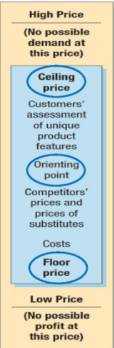

* + Markup pricing

Markup price =

= 1000/ (1-20%)

= 1000/ 0.8

= 1250

* + Target-return pricing
    - Price that yields its target rate of return on investment

Target-return price = unit cost +

= 1000 + [(200/0 x 1000]

= 1000 + [100,000/ 1000]

= 1100

* + Target-return pricing
    - Break-Even for Target-Return Price

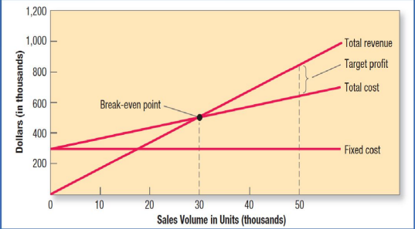

* + Perceived-value pricing
    - Based on
      * Buyer's image of product
      * Channel deliverables
      * Warranty quality
      * Customer support
      * Softer attributes (e.g. reputation)
    - To communicate and enhance perceived value in buyers' minds – Brands use the marketing program elements (advertising, sales force, and internet)
  + Value pricing
    - Fairly low price for a hiqh-quality offering to win loyal customers
    - Focused on re-engineering the company's operations to become a low-cost producer without sacrificing quality to attract a large number of value-conscious customers
    - E.g. IKEA & Southwest Airlines
  + EDLP
    - A retailer using everyday low pricing (EDLP) charges a constant low price with little or no price promotion or special sales (e.g. Walmart)
  + High-low pricing
    - Retailer charges higher prices on an everyday basis but runs frequent promotions with prices temporarily lower than the EDLP level
  + Going-rate pricing
    - Brands bases its price largely on competitors' prices
    - Useful where costs are difficult to measure or competitive response is uncertain
    - Reflects the industry's collective wisdom
  + Auction-type pricing
    - English auctions (ascending bids) - one seller and many buyers - seller puts up an item and bidders raise their offer prices until the top price is reached (e.g. Used cars/ Properties)
    - Dutch auctions (descending bids) —
      * One seller and many buyers - auctioneer announces a high price for a product and then slowly decreases the price until a bidder accepts
      * One buyer and many sellers - the buyer announces something he or she wants to buy, and potential sellers compete to offer the lowest price
    - Sealed-bid auctions - suppliers submit only one bid; they cannot know the other bids (e.g. Govt. or Company tenders)

### Step 6: Selecting the Final Price

* + Additional factors to select final price
    - Impact of other marketing activities
      * Brand's quality and Advertising relative to the competition
    - Company pricing policies
      * E.g. bank charges, Travel cancellation charges
    - Gain-and-risk-sharing pricing
      * Guarantee for promised value
    - Impact of price on other parties
      * Stakeholders - Dealers, Distributors, Sales force, Government, Competitors

## Other Pricinq Approaches & Strateqies

* Skimming
  + Products are sold at higher prices so that fewer sales are needed to break even
  + This strategy is employed only for a limited duration, to target "Early adopters"
* Loss Leader
  + Product sold at a low price to stimulate other profitable sales. This would help the companies to expand its market share as a whole.
* Penetration Pricing
  + Setting the price Iow in order to attract customers and gain market share.
* Differential Pricing
  + Different price for the same product in different segments to the market
* Premium Pricing
  + keeping the price of a product or service artificially high in order to encourage favourable perceptions among buyers, based solely on the price
* Psychological Pricing
  + Pricing designed to have a positive psychological impact. E.g. Rs. 99/- 149/-199/-
* Dynamic Pricing
  + A flexible pricing mechanism made possible by advances in information technology
  + E.g. App based taxi services, Airlines, E-commerce
* Freemium Pricing
  + offering a product or service free of charge (typically digital offerings such as software, content, games, web services or other) while charging a premium for advanced features.
  + E.g. LinkedIn, Hotstar